Upload Exam Papers
(1) Enter school name into the space of “school name”
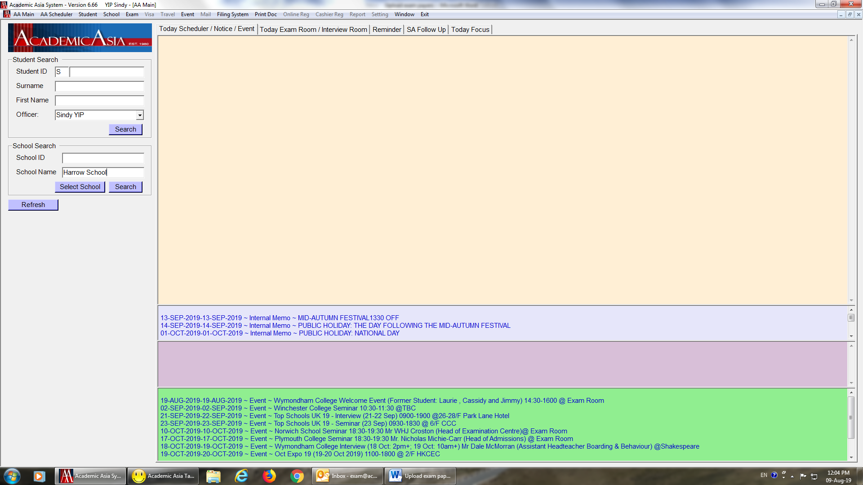
(2) Double click the highlighted, school profile will pop out afterward

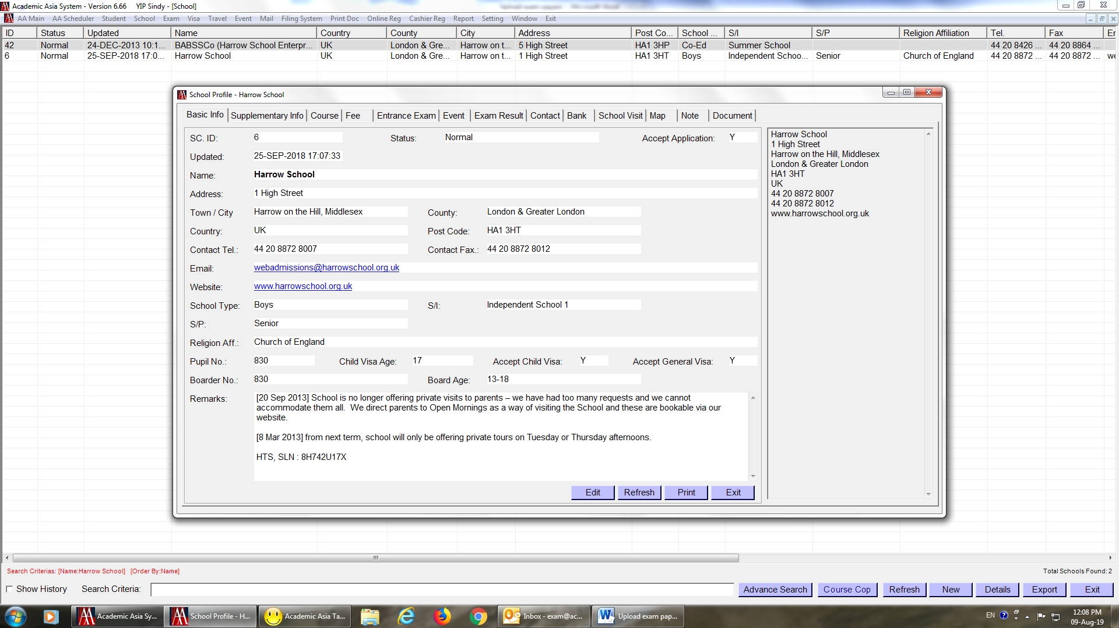
(3) Click “Entrance Exam” on school profile, then click “New” to start uploading exam paper
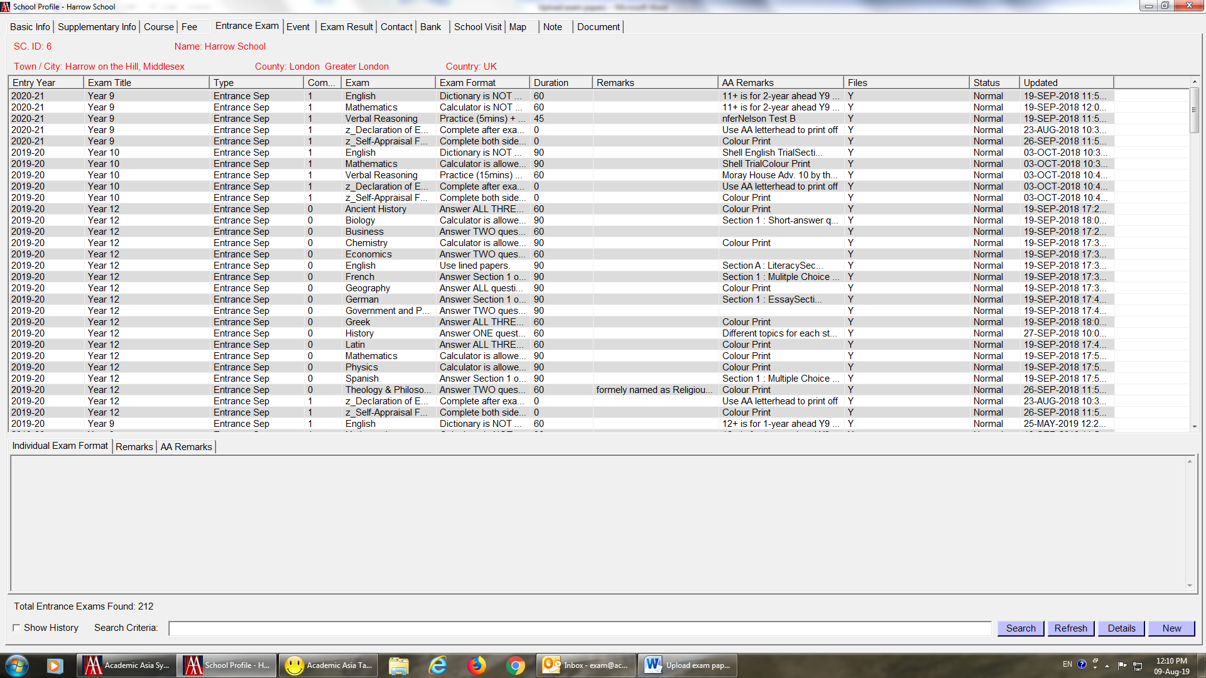

(4) After clicking “New”, a box will pop up for uploading exam details
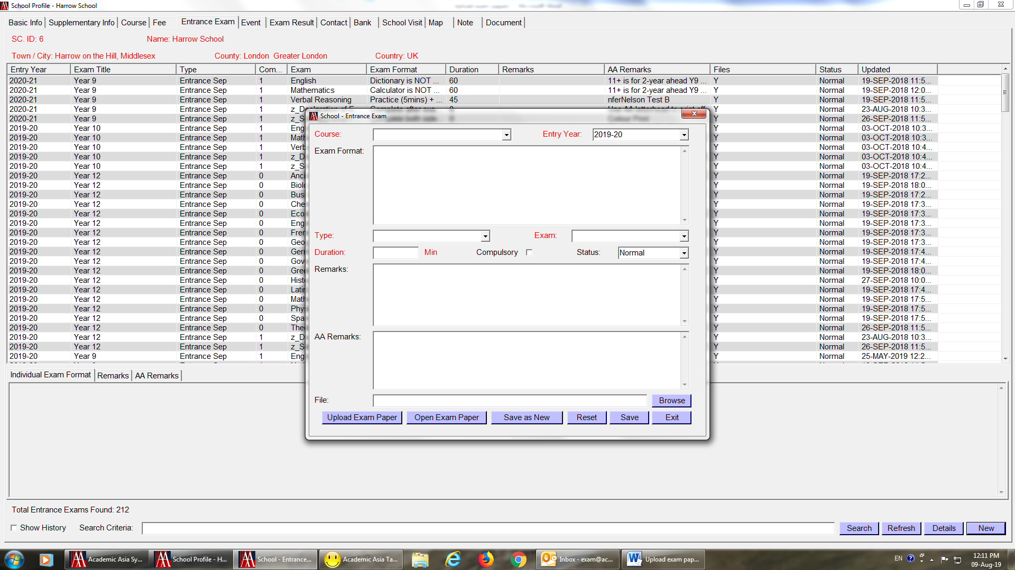
(5) Fill detail in column, then click “Save” after all information is filled.
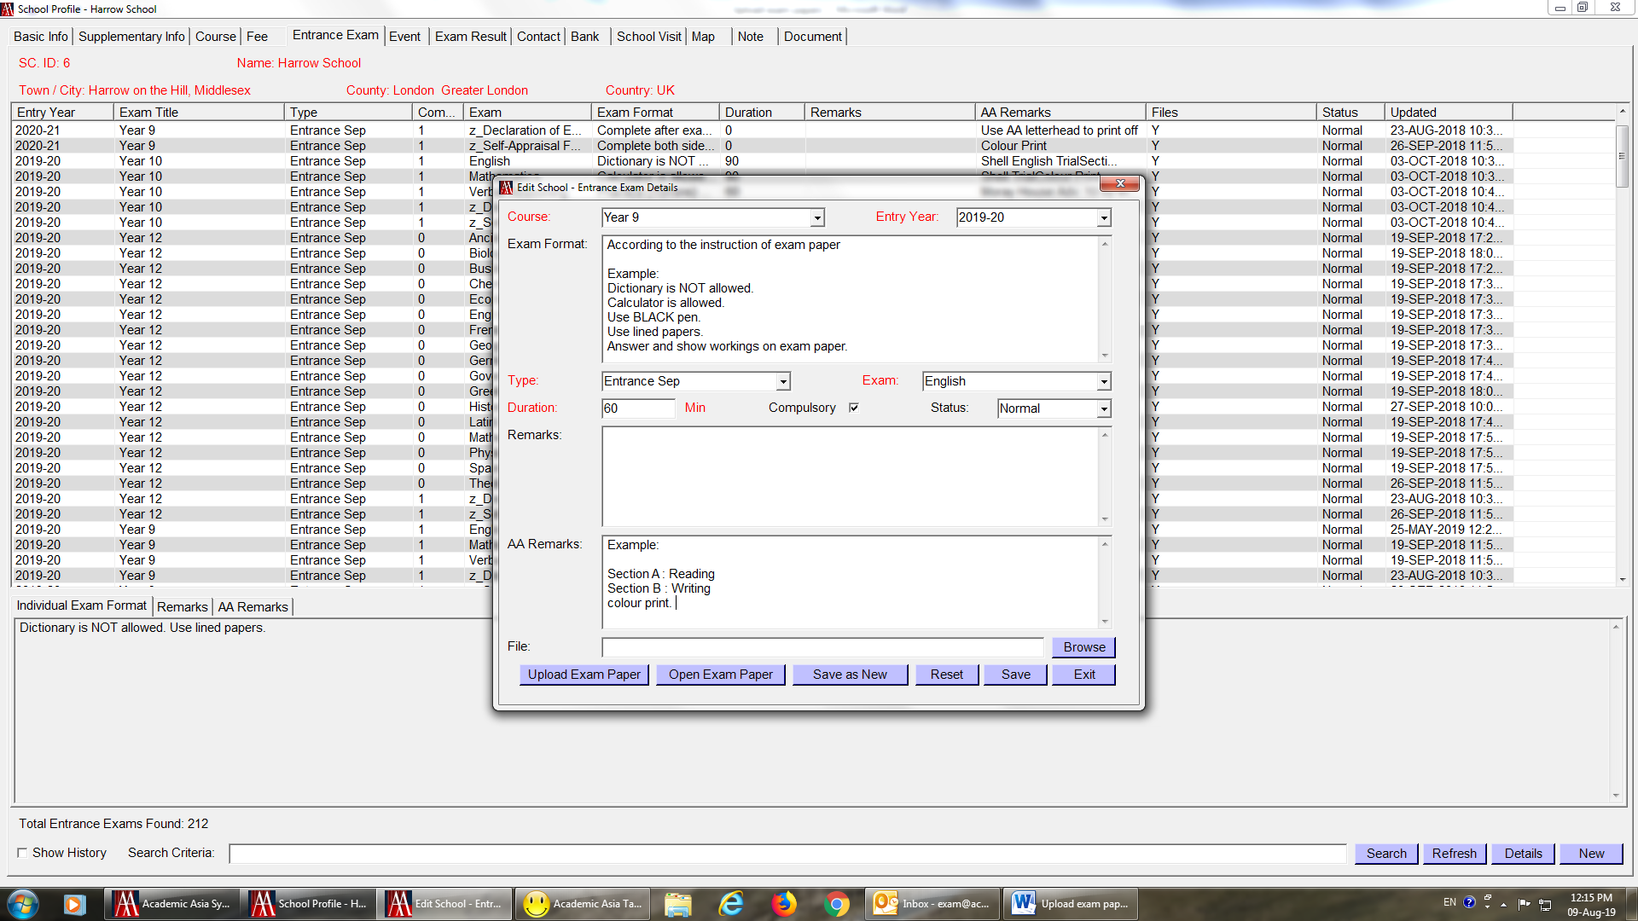

(6) Once click on “Save”, you will see below capture
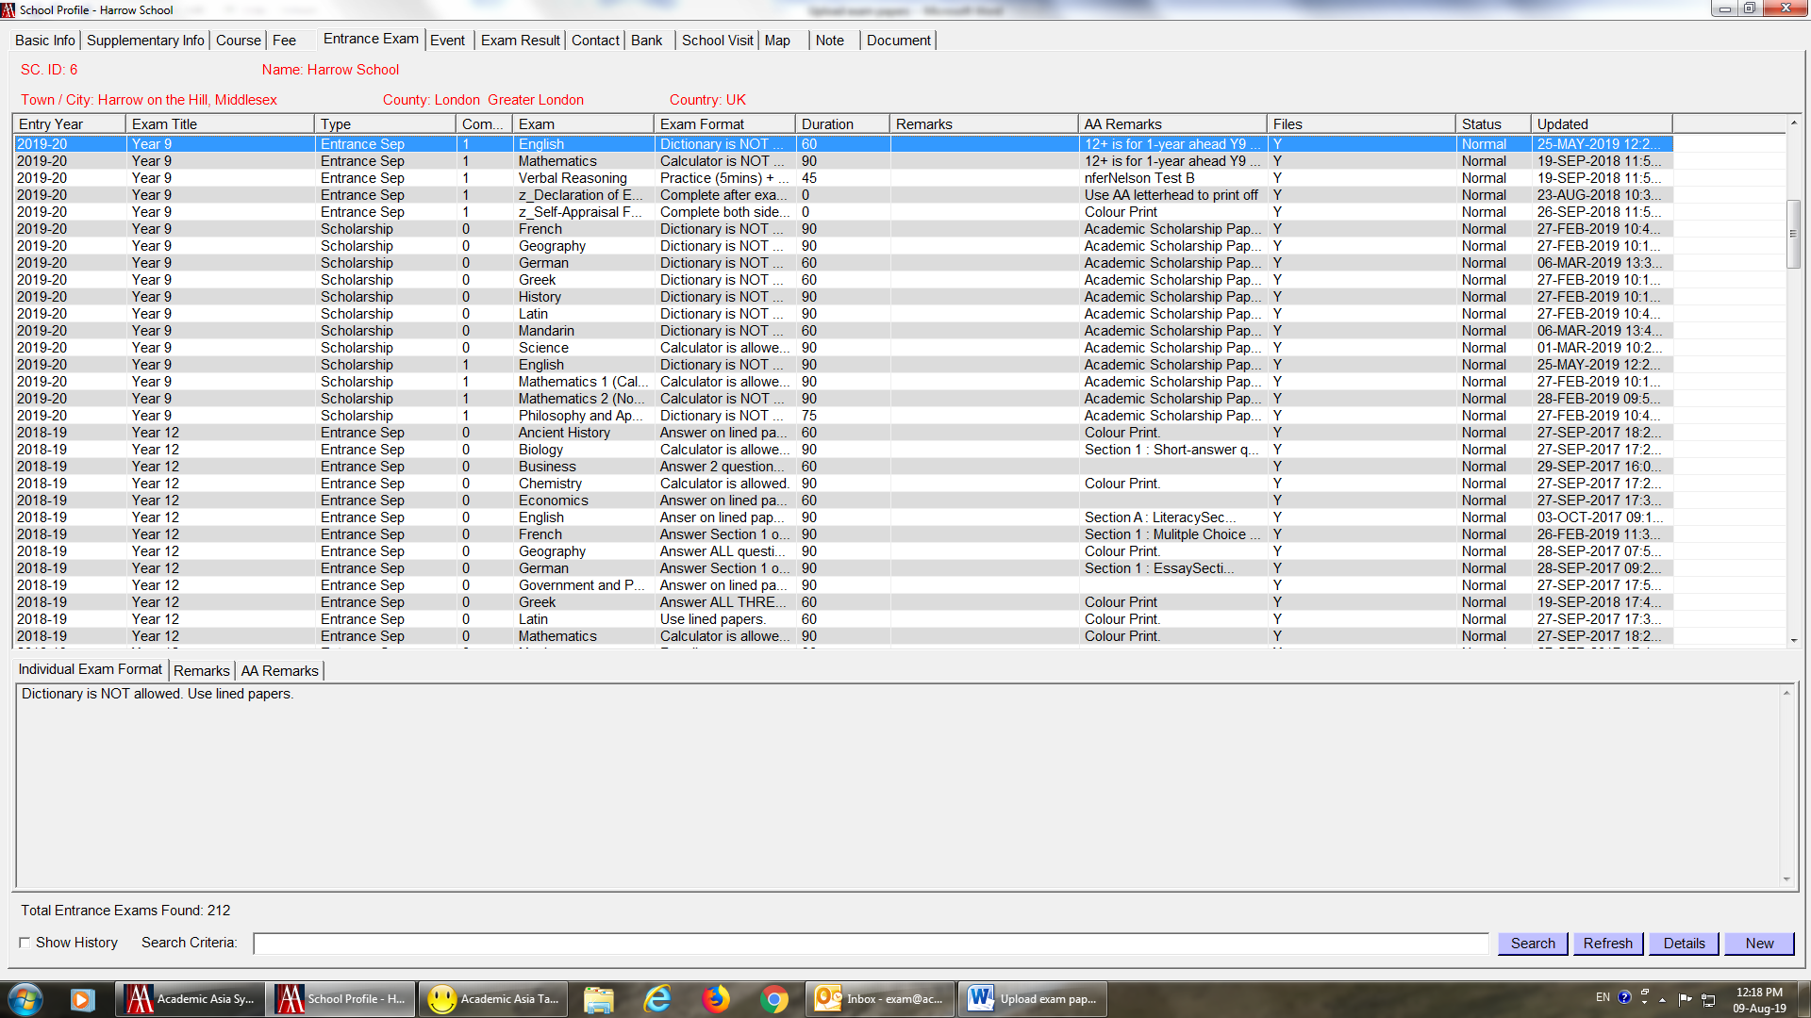
(7) Click “Browse” and locate the exam paper, then click on “upload exam paper” and “save”
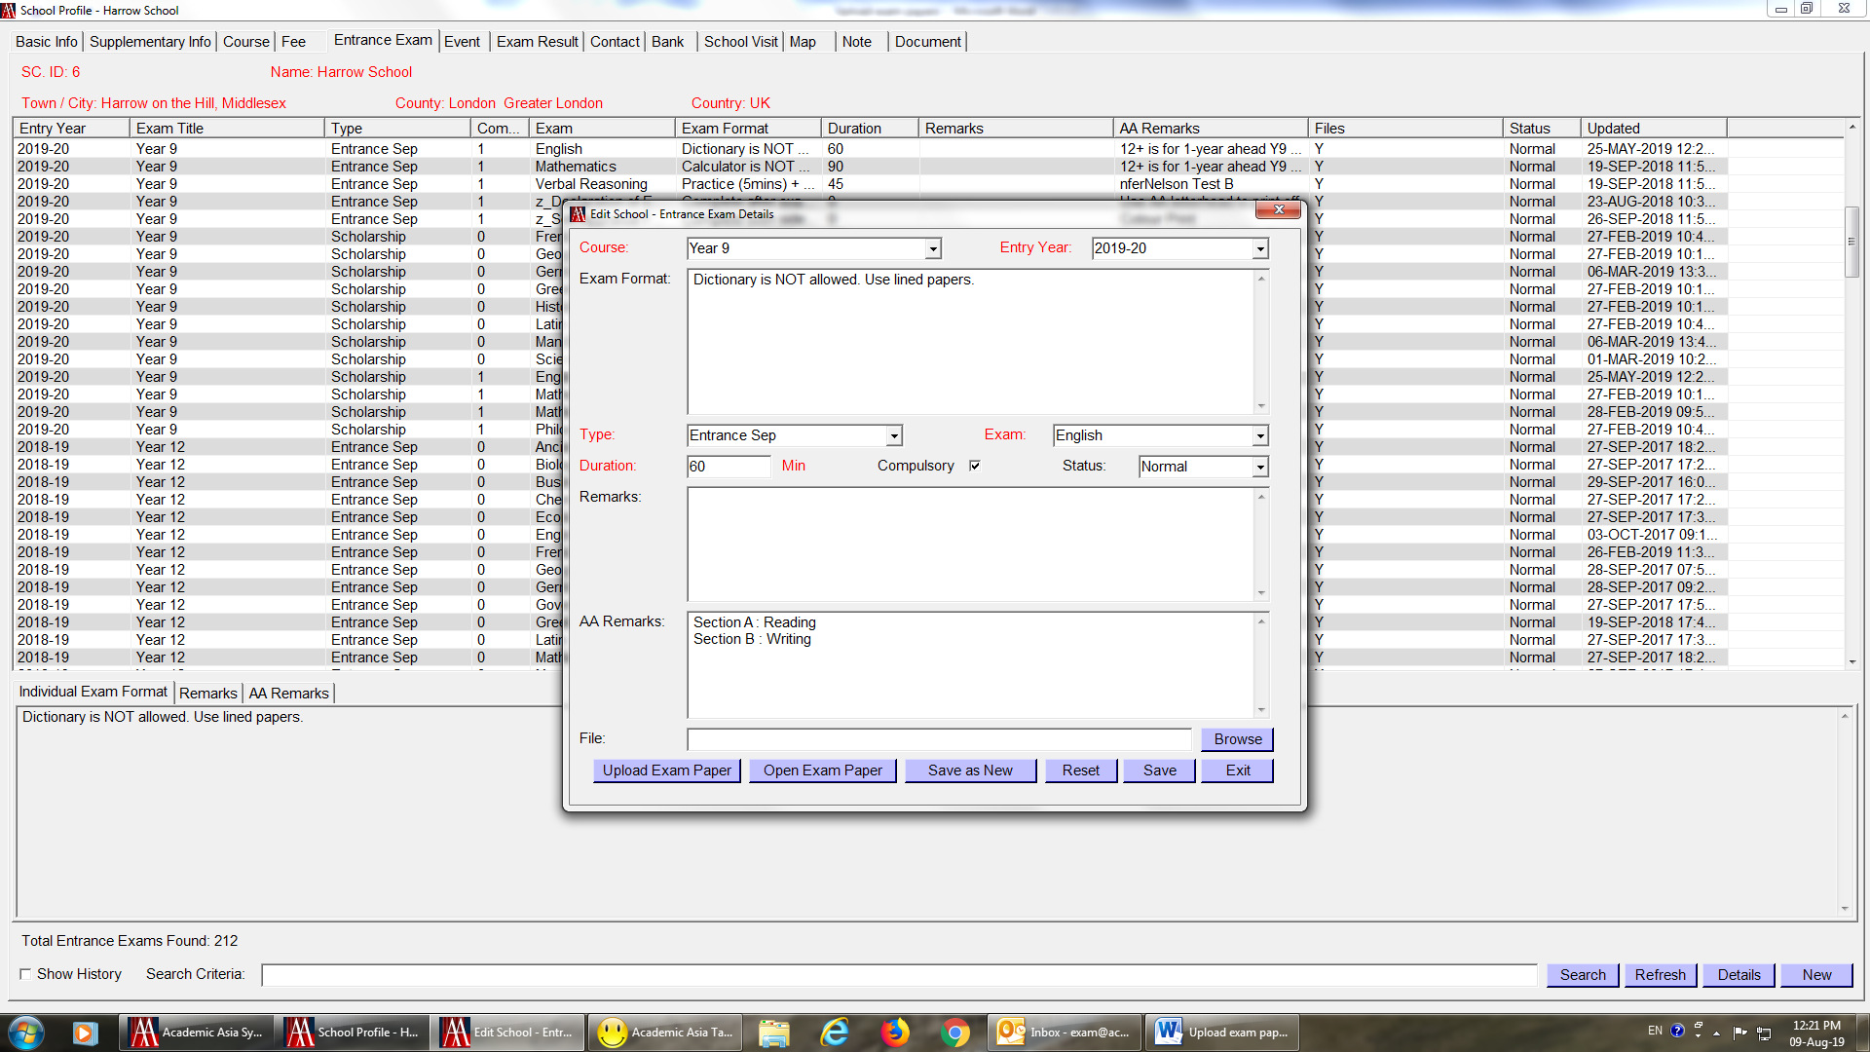
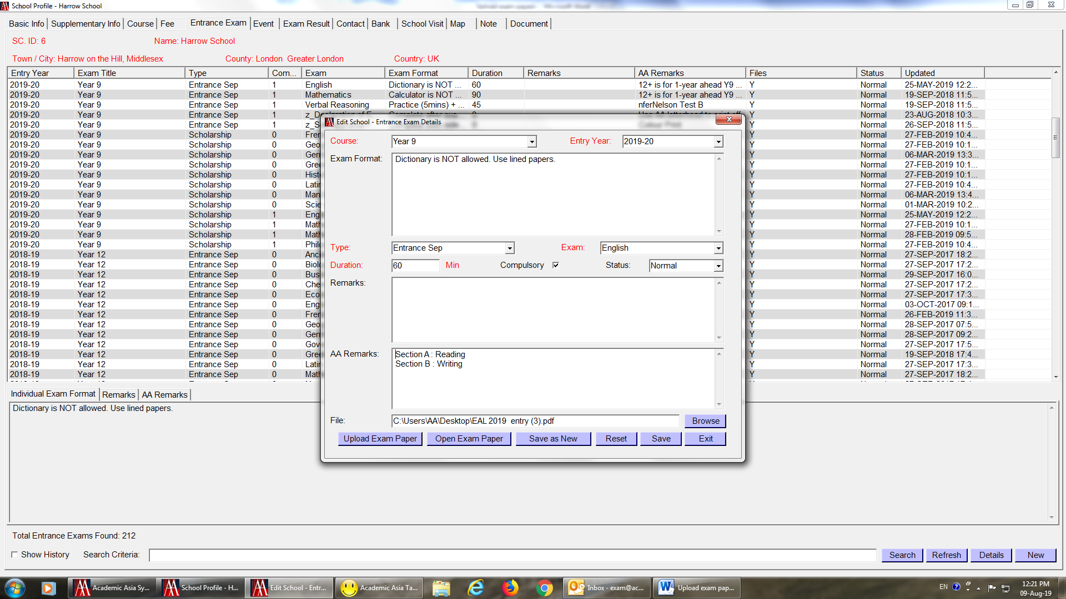
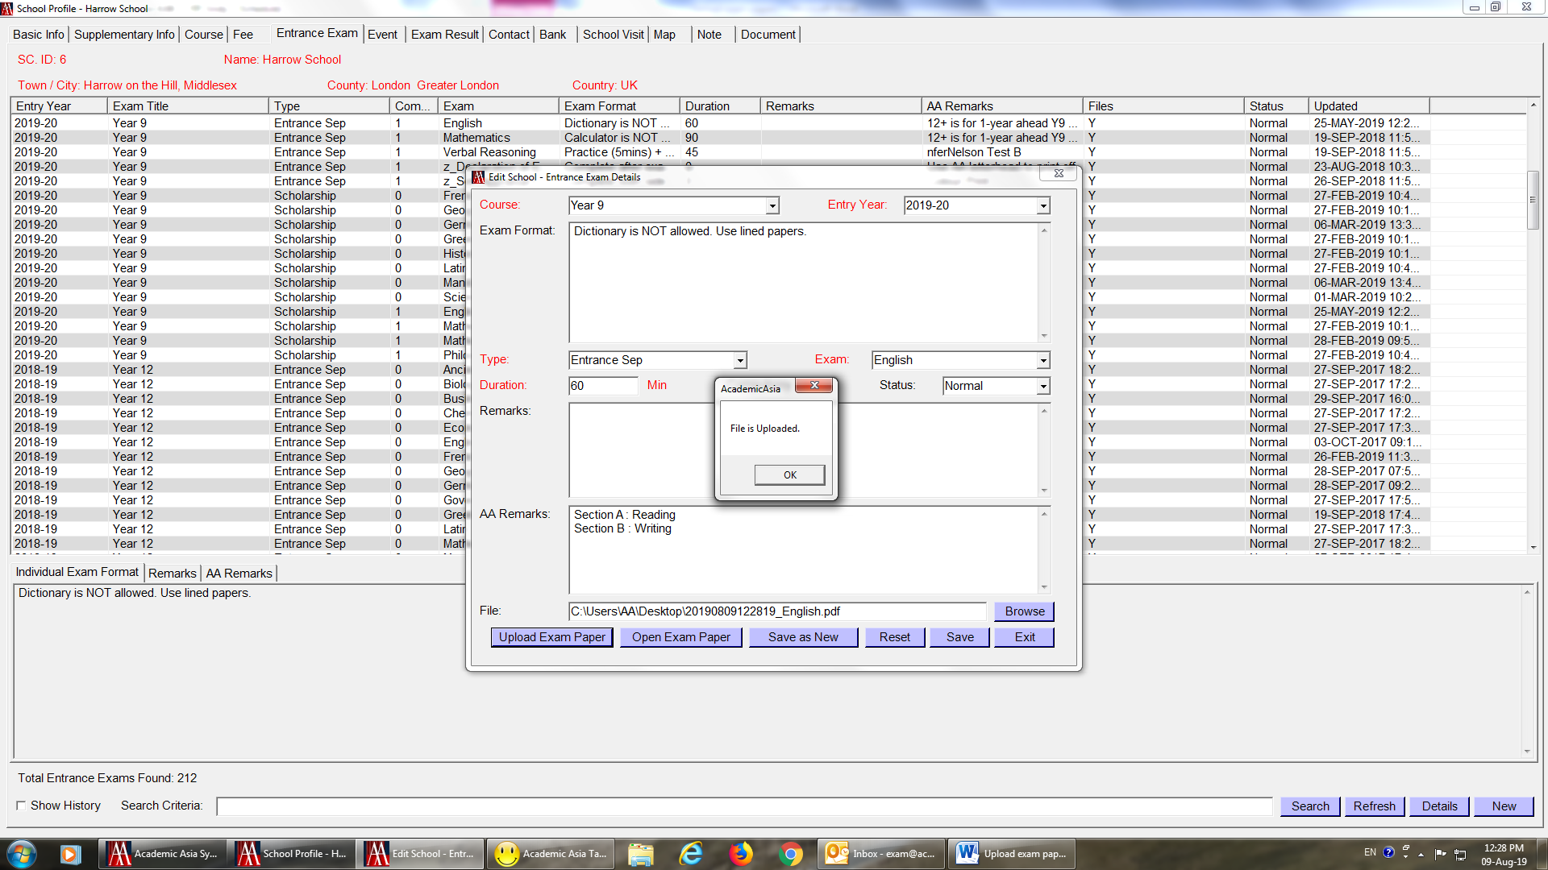

(8) Click “open exam paper”, then you can see the paper you have just uploaded
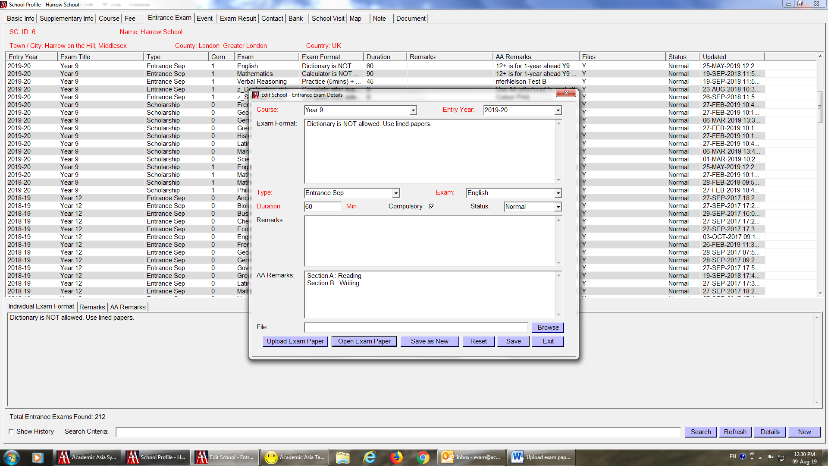
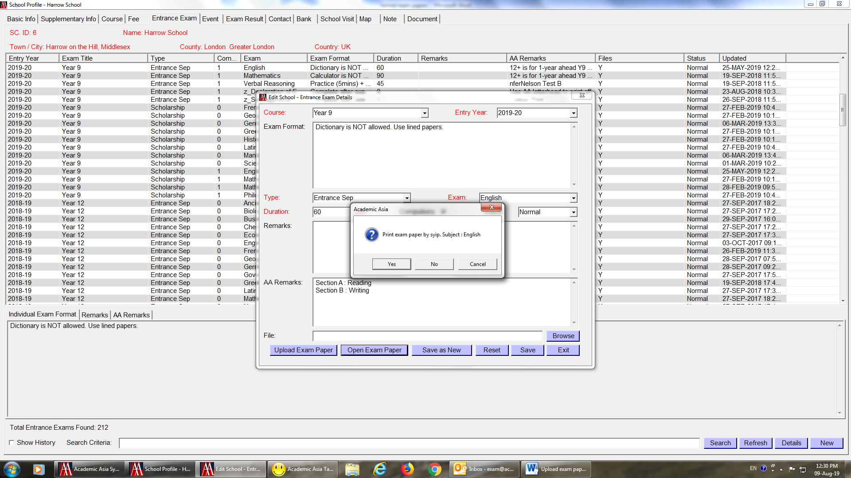

(9) After uploading all exam papers for the year group as below capture, click “Course”
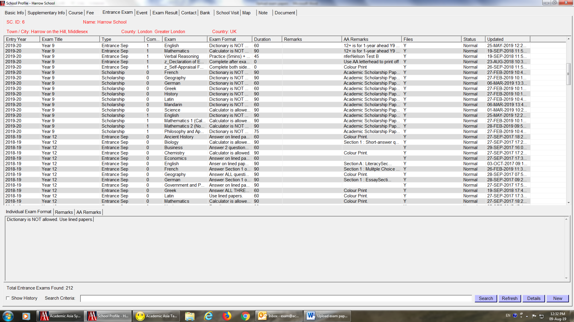
(10) Double click the year group exam papers just uploaded
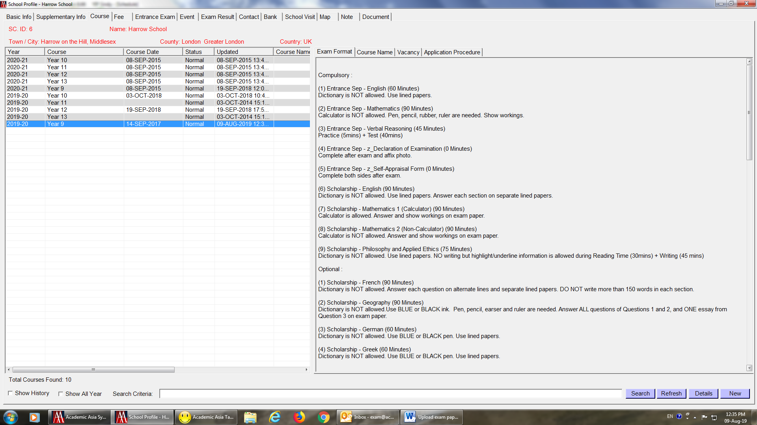

(11) A bow will pop up and fill ion the detail on “Exam Format”
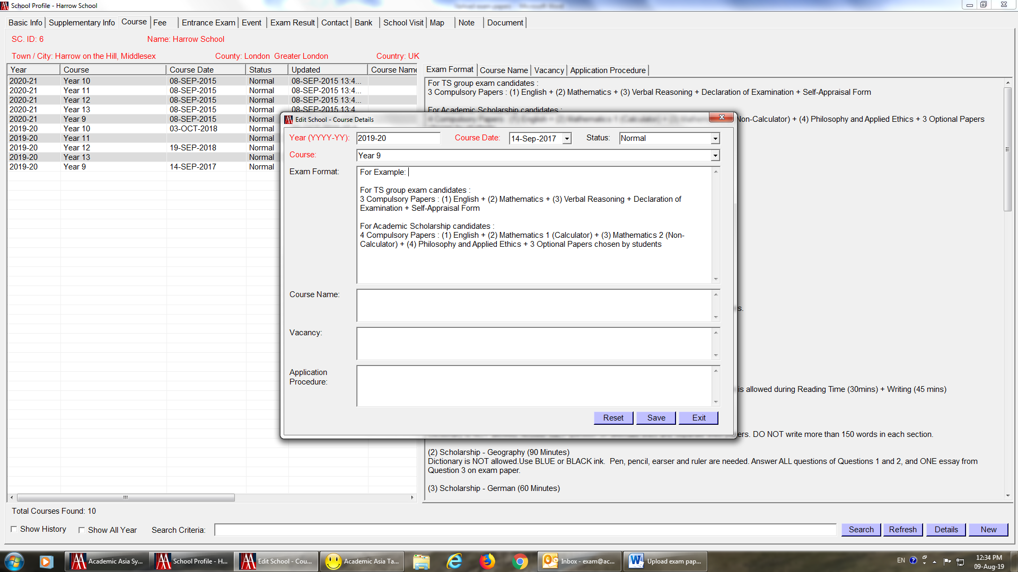
(12) After filing in the detail on “Exam Format”, click “Save”


(13) Then you can see the details appeared on the right hand side
